Lab 8
Leader: Manny Cabaya
Members: Melinda Nipes
Kecel Dujali
Shine Tayogandaga
Isabel Ingrid Monarca
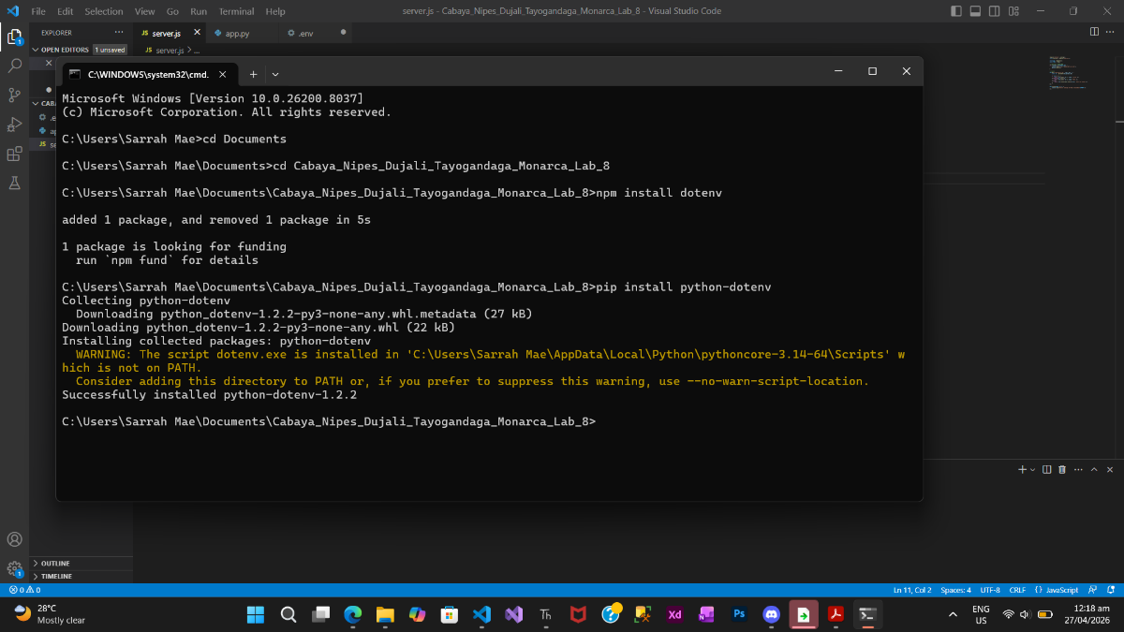

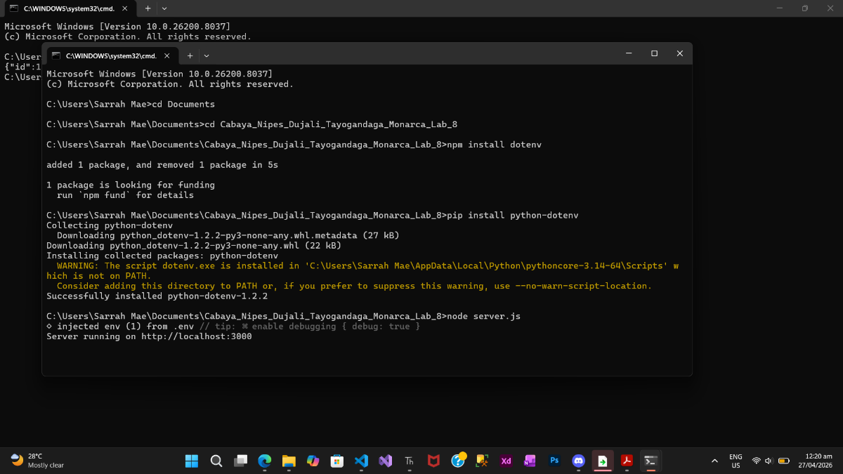
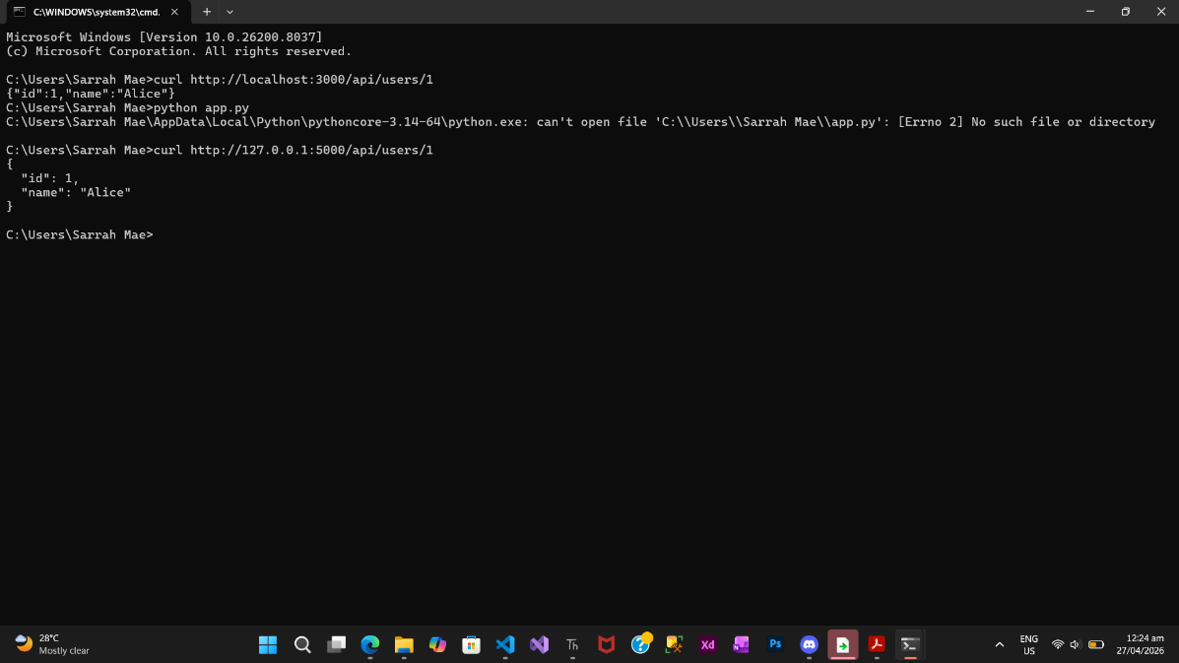
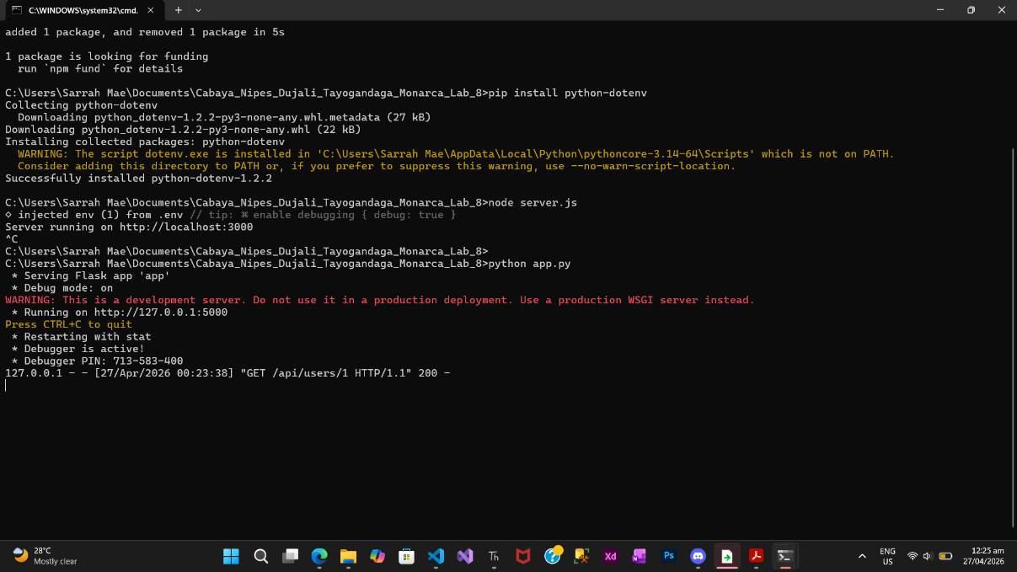

Lab Questions
- The Parameter Contract: How does the way Express captures a URL parameter (req.params) differ from the way Flask handles it (as a function argument)? Which feels more "natural" to you?
- Express captures URL parameters using req.params.id, which requires accessing the parameter from the request object. In Flask, the parameter is passed directly as a function argument (id), making it feel more natural and similar to regular function usage. Overall, Flask’s approach is simpler and easier to read.
- Error Handling: In Express, you chain methods (res.status().json()). In Flask, you often return a tuple. Which approach do you think is easier to read when building a large API with many different error types?
- Express uses method chaining like res.status(404).json(...), while Flask returns a tuple such as (jsonify(...), 404). Flask’s approach is easier to read because both the response and status code are clearly shown together, especially in larger APIs with many error cases.
- Language vs. Protocol: You just built the same API in two different languages. Did the curl command you used to test them change at all?
- The curl command did not change when testing both APIs.

- Reflection: Why is it a benefit to the "Client" (the user of the API) that the "Server" can change languages without breaking the connection?
- This is beneficial for the client because APIs follow standard HTTP protocols. The client does not need to know what language the server is written in. This allows developers to change or upgrade the backend (e.g., from Express to Flask) without affecting how clients interact with the API.
- Environment Abstraction: Why is using a .env file better than typing your secret key directly into the server.js or app.py file?
- Using a .env file is better because it keeps sensitive information like secret keys separate from the main code. This improves security by preventing secrets from being exposed in source code or version control. It also makes configuration easier to manage across different environments (development, testing, production).

